Summer BBQ/ Picnic
How would you throw a summer BBQ/ Picnic party?
Ex:
- My picnic will be at Sueyoshi Park.
- I hope the weather is sunny with clouds and slightly windy.
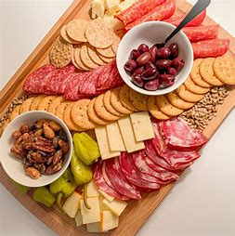
- The food will be a charcuterie board (a cheese, meat, crackers, and fruit board).
- The drinks will be iced tea or water.
- I will invite friends.
- We will all draw something together.
- What makes my picnic unique is that we will only speak English.

- Where is it?

- What is the weather like?

- What is the food?

- What are the drinks?

- Who will be invited?

- What will you do?

- Why is it unique?

