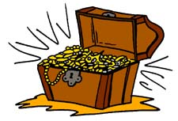
まず、宝箱を５個書いてください！
 | …tomorrow. | …on Sunday. | …in two weeks. | …next month. | …in three years.
I will play basketball…
She will eat natto…
He will go to Okayama…
Ken will make sushi…
They will watch TV…

宝箱が全滅したら負けです。

