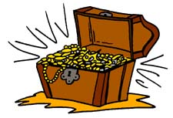
まず、宝箱を５個書いてください！

 | …for two weeks. | …since last year. | …for a long time. | …since March. | …for three years. | …since 2004.
She has played basketball…
I have eaten natto…
I have known Mr Osaka…
You have spoken English…
Ken has made sushi…
I have read books…

宝箱が全滅したら負けです。

