My vacation!

I’m going to ____________________.

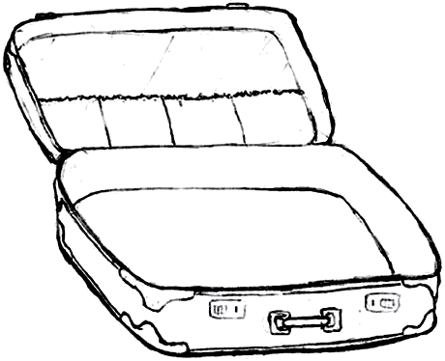

What will you take?

1) I’ll take a ______________________________ because I want to
______________________________________.
2) I’ll take a ______________________________ because I want to
______________________________________.
3) _____________________________________________________
_______________________________________________________.
4) _____________________________________________________
_______________________________________________________.
Examples

- I want to take pictures.
写真を撮りたい。
  - I want to be warm.
あたたかくなりたい。
    - I want to play tennis.
テニスをしたい。
      - I want to climb a mountain.
山を登りたい。
        - 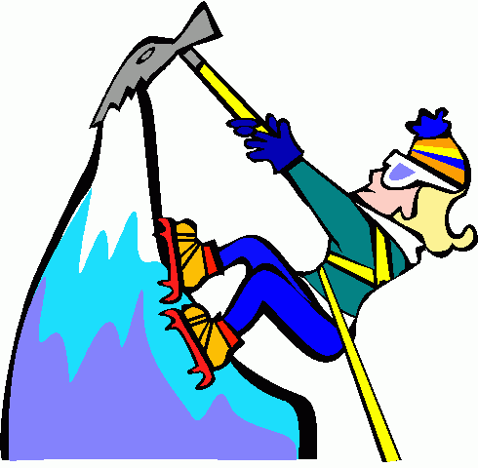I want to swim in a lake.
湖に泳ぎたい。

