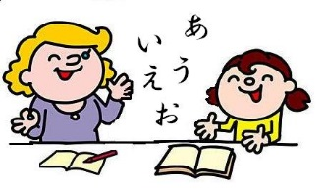
Useful Japanese words

There are many people around the world who are learning Japanese! Please help them!

My word: ________________________________

What does it mean?

When is it used?

What words did your friends choose?

name | What word? | What does it mean? | When is it used?
