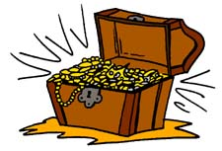
Hidden Treasure!
まず、宝箱を５個書いてください！
 | …watching a movie last night. | …playing basketball at 7. | …making rice balls this morning. | …studying English on Sunday. | …eating natto  at 11.
She was…
Ken and Kumi were…
I was…
My friends
were…
Was he…?

宝箱が全滅したら負けです。

