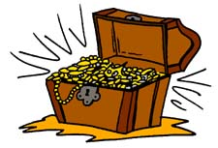
まず、宝箱を５個書いてください！
 | …is played  every day. | …is known by everyone. | …was made  in Italy. | …is loved by many children. | …is watched  on TV.
Basketball…
Soccer…
Tennis…
Shogi…
Volleyball…

宝箱が全滅したら負けです。

