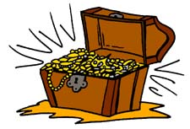
まず、宝箱を５個書いてください！
 | …yesterday. | …two days ago. | …last week. | …three months ago. | …in January.
I wrote
a letter…
She went to Kanagawa…
My brother
made pizza…
Emma bought dorayaki…
She practiced basketball…

宝箱が全滅したら負けです。

