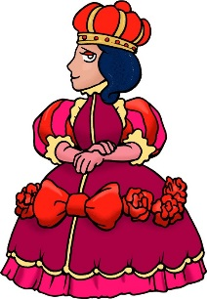
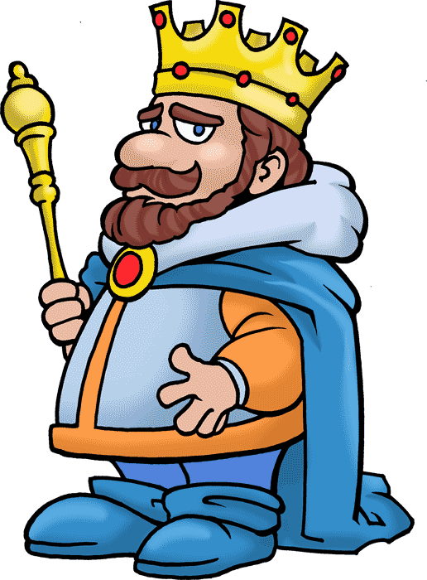
I’m the King! I’m the Queen!

- Go to ______________________________________________ on Saturday.
Okay!  ________ ________ ________  ________ ________ ________  ________ ________ ________ | No thanks…  ________ ________ ________  ________ ________ ________  ________ ________ ________

- Eat __________________________________________________ every day.
Okay!  ________ ________ ________  ________ ________ ________  ________ ________ ________ | No thanks…  ________ ________ ________  ________ ________ ________  ________ ________ ________

- Don’t play _______________________________________________________.
Okay!  ________ ________ ________  ________ ________ ________  ________ ________ ________ | No thanks…  ________ ________ ________  ________ ________ ________  ________ ________ ________

