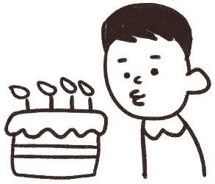
Name: ________________

Teacher birthdays!

It’s ______________________’s birthday!

What will you give him / her ?

name | present | name | present

Name: ________________

Teacher birthdays!

It’s ______________________’s birthday!

What will you give him / her ?

name | present | name | present

