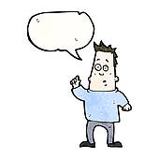Class Survey

 | ___________ | or | ____________ ?
 | _________ _________  _________ _________  _________ _________  _________ _________  _________ _________  _________ _________  _________ _________  _________ _________  _________ _________ |  | _________ _________  _________ _________  _________ _________  _________ _________  _________ _________  _________ _________  _________ _________  _________ _________  _________ _________
your total:
partner total:
final total:

