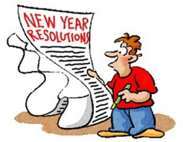
My New Year’s Resolutions

What are your resolutions for the new year?

- ______________________________________________
______________________________________________
- ______________________________________________
______________________________________________

How about your friends?

name | Resolutions
