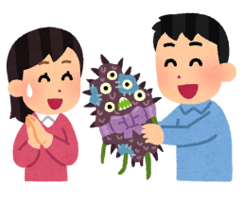
The Least Popular Things

Do you like ____________?

No, I don’t.

Why not?

They’re too _________!

Thing | Person | Why not?

What did your friends say?

例： Maki doesn’t like umeboshi because it’s too sour.

- ___________________________________________________
- ___________________________________________________
- ___________________________________________________
- ___________________________________________________

