Doraemon  HINT 1: He was made in 2112.  HINT 2: He was bought by Sewashi.  HINT 3: __________  _________________  _________________  Who is he? | Hayashi Osamu  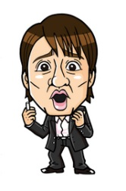  HINT 1: He was born in 1965.  HINT 2: He is known for saying “Ima deshou!”.  HINT 3: __________  _________________  _________________  Who is he? | Anpanman  HINT 1: He can be eaten.  HINT 2: He was made by Jam Oji-san.  HINT 3: __________  _________________  _________________  Who is he?
Fish  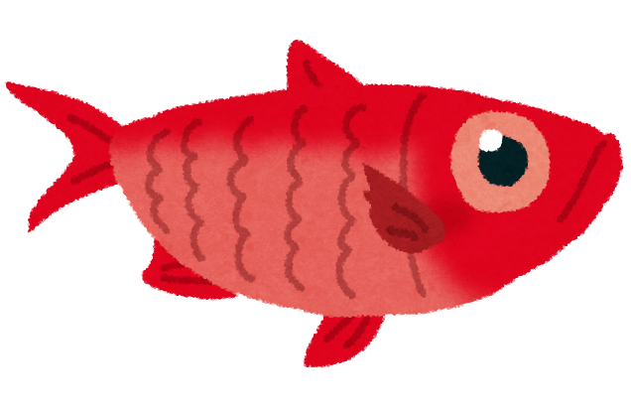  HINT 1: They are used in sashimi.  HINT 2: They are eaten by cats and bears.  HINT 3: __________  _________________  _________________  What are they? | Dorayaki  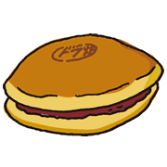  HINT 1: It’s eaten in Japan.  HINT 2: It’s made of pancakes and azuki.  HINT 3: __________  _________________  _________________  What is it? | Books  HINT 1: They are made of paper.  HINT 2: They are sold in stores and train stations.  HINT 3: __________  _________________  _________________  What are they?
Apples  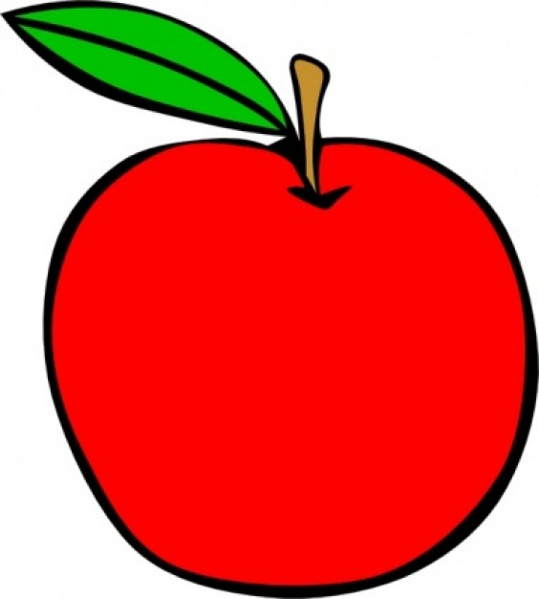  HINT 1: They are grown in Nagano and Aomori.  HINT 2: They are eaten in many countries.  HINT 3: __________  _________________  _________________  What are they? | Horses  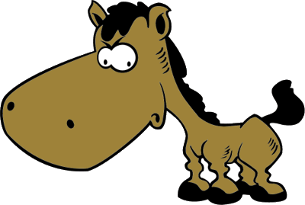  HINT 1: They are ridden by people.  HINT 2: They are used in basashi.  HINT 3: __________  _________________  _________________  What are they? | Ferrari  HINT 1: They are made in Italy.  HINT 2: They can be driven very fast.  HINT 3: __________  _________________  _________________  What are they?
Maccha  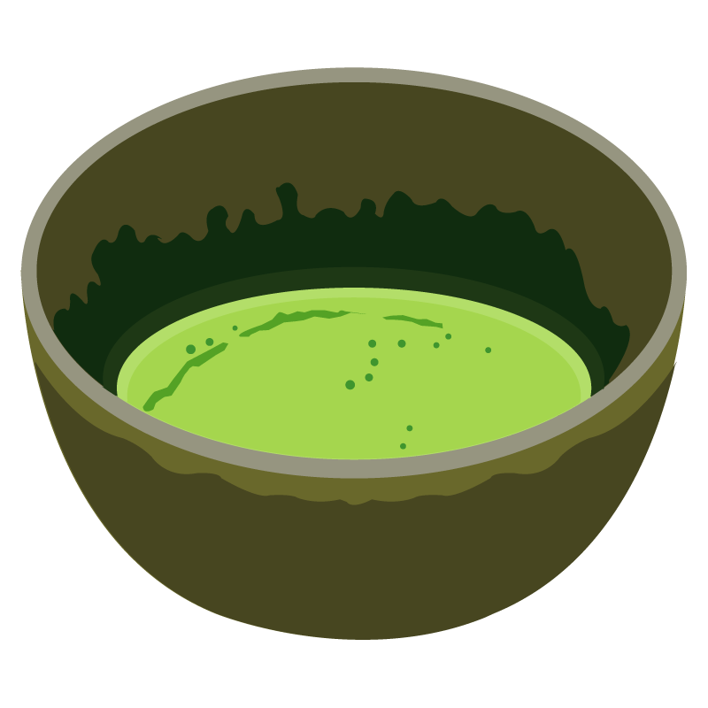  HINT 1: It’s drunk with Japanese sweets.  HINT 2: It can be used in ice cream.  HINT 3: __________  _________________  _________________  What is it? | Tacos  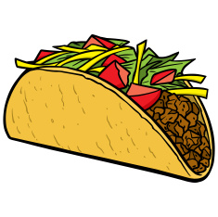  HINT 1: They are eaten in Mexico.  HINT 2: They are made with beans, cheese, and lettuce.  HINT 3: __________  _________________  _________________  What are they? | Gyoza  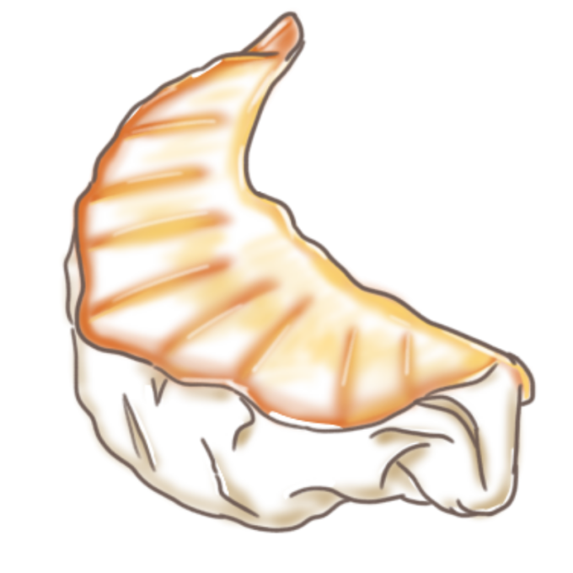  HINT 1: It’s made in Utsunomiya.  HINT 2: It’s eaten with ramen.  HINT 3: __________  _________________  _________________  What is it?

