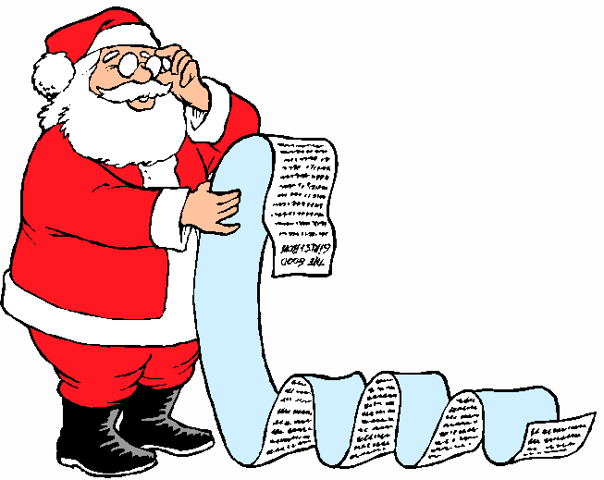My Letter to Santa

Dear Santa,

__________________________________________________________________

__________________________________________________________________

__________________________________________________________________

__________________________________________________________________

From,

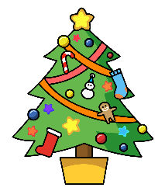

Dear

_________________________________________________________

_________________________________________________________