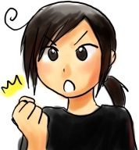
You start!!

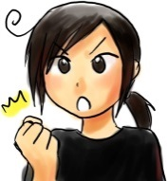
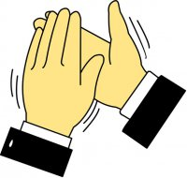
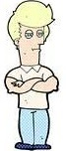
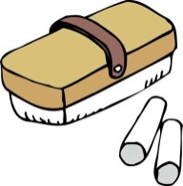
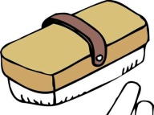
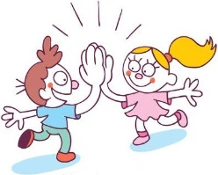
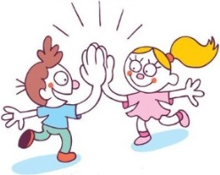
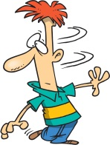
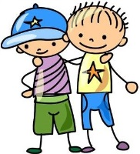
立って手を３回叩く。

Stand up and say loudly: “Hello everyone. Please do your best!”
立ち上がって大声でこう言います：“Hello everyone. Please do your best!”

…立ち上がって大声でこう言います：“Hello everyone. Please do your best!”

Stand up and clap your hands three times.
When you hear someone say “Hello everyone. Please do your best!”,
When you see someone stand up and clap their hands three times,

立ち上がって大声でこう言います：“good job everyone!”
黒板に行き、円を描いてから座ってください。
go to the blackboard, draw a circle and then sit down.
…立って手を３回叩く、

立ってあなたの名前を空中に書いてください。
stand up and write your name in the air.
…黒板に行き、円を描いてから座ってください、

When you see someone go to the blackboard, draw a circle and sit down,
先生（ケント）のところに行って、握手してすわってください。

go to the teacher (Kent), shake hands and then sit down.
…立ってあなたの名前を空中に書いてください、

When you see someone stand up and write their name in the air,
拍手して、応援してください。

clap your hands and cheer.
…先生（ケント）のところに行って、握手してすわってください、

When you see someone go to the teacher, shake hands and then sit down,

教室の後ろに行って、腕組みをして動かないでください。

go to the back of the room, fold your arms and don’t move.

…拍手して、応援してください、

When you see someone clap their hands and cheer,
黒板のところに行って、円を消して、すわってください。

go to the blackboard, erase the circles and then sit down.
…教室の後ろに行って、腕組みをして動かないでください、

When you see someone go to the back, fold their arms and stop moving,
立って、３人の人に「ハイ、５」と言ってください。

stand up and give three people a high five. (“Say high five!”)
…黒板のところに行って、円を消して、すわってください、

When you see someone go to the blackboard, erase the circles and sit down,
教室の後ろに行って、後ろにいる人をその人の座席に連れて行ってください。

go to the back of the room and take the students back to their chairs.
…立って、３人の人に「ハイ、５」と言ってください、

When you see someone stand up and give three people a high five,
立って、３回まわってください。
stand up and turn around three times.
…教室の後ろに行って、後ろにいる人をその人の座席に連れて行ってください、

When you see someone go to the back and take students to their chairs,

stand up and say loudly “good job everyone!”
…立って、３回まわってください、
When you see someone stand up and turn around three times,

B
I
H
E
A
J
F
D
K
L
G
C
I

B

E

H

J

A

D

F

L

K

C

G
You start!!

G
C
K
L
F
D
A
J
H
E
B
I
go to the back of the room, fold your arms and don’t move.

Stand up and clap your hands three times.

Stand up and say loudly: “Hello everyone. Please do your best!”

stand up and say loudly “good job everyone!”

When you see someone stand up and turn around three times,

stand up and turn around three times.

When you see someone go to the back and take students to their chairs,

go to the back of the room and take the students back to their chairs.

When you see someone stand up and give three people a high five,

stand up and give three people a high five. (“Say high five!”)

When you see someone go to the blackboard, erase the circles and sit down,

go to the blackboard, erase the circles and then sit down.

When you see someone go to the back, fold their arms and stop moving,

When you see someone clap their hands and cheer,

clap your hands and cheer.
When you see someone go to the teacher, shake hands and then sit down,

go to the teacher, (Kent) shake hands and then sit down.

When you see someone stand up and write their name in the air,

stand up and write your name in the air.

When you see someone go to the blackboard, draw a circle and sit down,
go to the blackboard, draw a circle and then sit down.

When you see someone stand up and clap their hands three times,

When you hear someone say “Hello everyone. Please do your best!”,

This a warmup game, probably better suited for third grade JHS (without the Japanese translations), but it can be used for any grade (with the Japanese translations)

Cut the sheet (or sheets) into the 12 separate slips. For a class of between 12 and 24 , cut up 2 pages, and for a class of between 24 and 36, cut up 3 pages.

Hand out the slips to the students. You can either hand them out randomly or, if you think the students would benefit from having other students close to them with the same slips, hand them out in bunches.

Try to have at least 2 people doing the same action.

Let the students figure out what they have to do for a minute or two, then ask them to perform each action, following on from the previous action.

The students may be hesitant the first time round, but if you let them do it a second time they will know what to do and it’ll go much faster and be more fun.

This activity can be done numerous times over the year as long as the students receive a new slip each time.

