Name: Class: Number:
Sure !
Will you shake my hand, please??

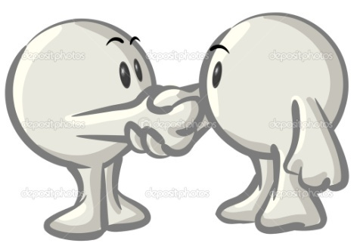

Play Rock, Paper, Scissors !
Start!
Winner = A & Loser = B (Loser must sign their name.)
A: Will you write your name in Japanese?
B: OK, no problem.

^Write Japanese here. ^
Sign:
A: Will you shake my hand, please?
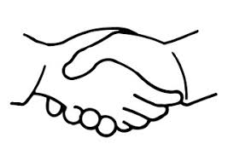
B: Sure!.
Sign:

A: Will you say, “Hello” to me, please?

B: Yes, I will. Hello!
Sign:

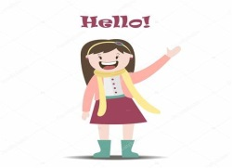

A: Will you open the window, please?

B: No, I won’t. It’s rainy outside.
Sign:
A: Will you give me 500 yen, please?

B: I’m sorry. No, I will not…
Sign:
A: Will you draw a happy face on my paper, please?

B: OK!
Sign:

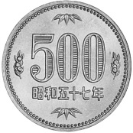
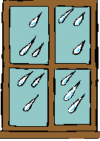

^Draw happy face here.^

A: Will you say, “Hello” to the ALT, please??

B: Sure! Hi OO !
Sign:
A: Will you sign my paper, please?

B: Sure!
Sign:
A: Will you help me, please?

B: Sorry, I’m busy!
Sign:

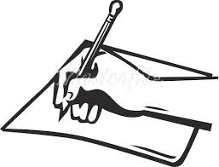
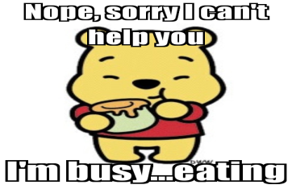

ALT’s signature:

__________
Rank
Finish!

___________________________

Ｂさんの紙のどこでも書いて
Ｂさんの紙のどこでも書いて

BRIEF OUTLINE: Students ask 9 "Will you~?" questions to friends while trying to advance by winning rock, paper, scissors.

MATERIALS NEEDED:
- Will You, May I worksheet

DETAILED EXPLANATION:
- Students start at the first question and play rock, paper, scissors.
- The winner asks the question and the loser completes the action.
- The winner then receives the losers signature and moves on to the next question. The students find new partners and repeat.
- When a student finishes all 9 questions, he or she will come to the ALT to receive a big signature.

TEACHING SUGGESTIONS:
- Be sure to teach 'happy face' and draw it on the board. ('nikkochan mark', not 'ureshii kao')
- When signing your name, be sure to include a numerical rank so that students can check their status and be more competitive.

