Name___________________________ Class _____ Number_____

**Which bus goes to...**

. Excuse me. Which bus goes to

. Yes.

. I see. Where should we get off?

. How long does it take?

. Thank you.

. ~~~~ ?

. Take bus No. ~~~~ . It stops over there.

A bus arrives every ~~~~ minutes.

. Get off at ~~~~ street.

. Oh…I think it takes about ~~~~ minutes.

. You’re welcome.



1. **Ikebukuro station?** 2. **the pool?**

3. **the music store?** 4. **the post office?**

Kim

Jenny

Sam

Jack

Read the dialogue with your partner and fill in the blanks.

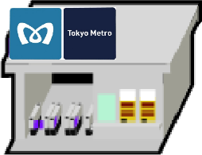

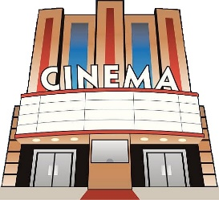

**Star Wars**

**Ikebukuro station**

**_________ street**

**______ minutes**

**The supermarket**

**Jim street**

**30 minutes**

**The post office**

**________ street**

**______ minutes**

**The cinema**

**Tom street**

**20 minutes**

C:\Documents and Settings\itteacher.OIMATU-J8\Local Settings\Temporary Internet Files\Content.IE5\ZGOW3UK2\MCj02957320000[1].wmf



j0236680

**The pool**

**________ street**

**______ minutes**

**The music store**

**_________ street**

**______ minutes**



**Oizumigakuen junior high school**

**Alex street**

**7 minutes**

**The hospital**

**Hana street**

**4 minutes**

**It takes about**

**Bus number**

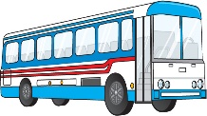

1

99

every

______ minutes.

every

minutes.

every

______ minutes.

every

minutes.

13

20

Name___________________________ Class _____ Number_____

**Which bus goes to...**

. Excuse me. Which bus goes to

. Yes.

. I see. Where should we get off?

. How long does it take?

. Thank you.

. ~~~~ ?

. Take bus No. ~~~~ . It stops over there.

A bus arrives every ~~~~ minutes.

. Get off at ~~~~ street.

. Oh…I think it takes about ~~~~ minutes.

. You’re welcome.



1. **the hospital?** 2. **the cinema?**

3. **the supermarket?** 4. **Oizumigakuen JHS?**

Tom Jim

Hana

Alex

Read the dialogue with your partner and fill in the blanks.





**It takes about**

**Star Wars**

**Ikebukuro station**

**Jenny street**

**12 minutes**

**The supermarket**

**_________ street**

**_______ minutes**

**The post office**

**Kim street**

**35 minutes**

**The cinema**

**________ street**

**______ minutes**

C:\Documents and Settings\itteacher.OIMATU-J8\Local Settings\Temporary Internet Files\Content.IE5\ZGOW3UK2\MCj02957320000[1].wmf



j0236680

**The pool**

**Jack street**

**15 minutes**

**The music store**

**Sam street**

**10 minutes**



**Oizumigakuen junior high school**

**__________ street**

**________ minutes**

**The hospital**

**_______ street**

**______ minutes**

**Bus number**



38

57

every

minutes.

every

______ minutes.

every

minutes.

every

______ minutes.

6

15

This Activity is for New Horizon 2, page 78, “Which bus goes to the palace theatre?”

This activity is similar to an activity I created last year, but I’ve spent a lot of time changing almost everything to make it simpler.

First and foremost, I’ve reduced the number of worksheets to only one for each student, (A and B), and secondly, I’ve tried to make it easier to understand generally.

The A and B worksheets are handed out to the class equally as pair work (with the JTE making up one half of a pair if there are odd numbers), and students can janken to decide who starts.

The first student (A) asks, (from the A worksheet) “Excuse me. Which bus goes to Ikebukuro station?”

The place names are in the word box numbered 1 to 4 to make it easier.

B student then looks at the map, finds Ikebukuro station, traces the road back to the bus stop at the bottom of the page, and relays the information back to his/her partner using the dialogue as a guide.

Student A writes down the information he/she hears from B, and they both continue this process while using the dialogue as a guide.

Each student has four chances to ask a question.