Give me advice
1. I want to be a pro athlete  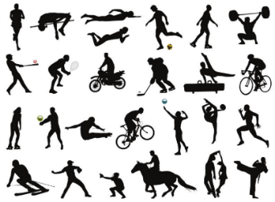  I want to know what I have to do | 2. I want to be an architect after high school  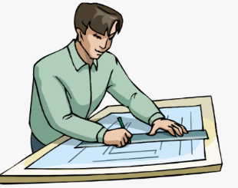  I want to know where I can study | 3. I want to learn how to swim  I want to know how I can get better  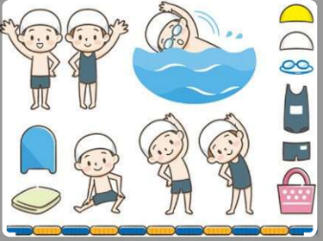
4. I want to use more English  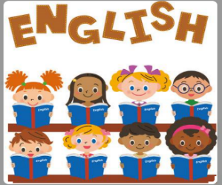  I want to know what I can do in English classes | 5. I want to make Matcha at home  I want to know how I can do this | 6. I want to play the guitar better  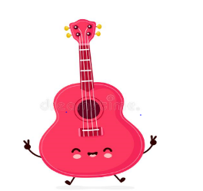  I want to know what I can do
7. I want to be a singer  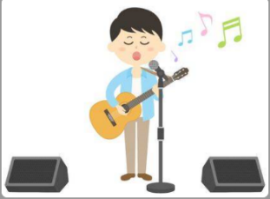  I want to know what I have to do | 8. I want to be a vet  I want to know how I can do this | 9. I want to be a teacher  I want to know how I can do this

1 | 2 | 3 | 4 | 5 | 6 | 7 | 8 | 9

Name: ____________________________________________No_____Class:_____ Date: ________________________.

1.  I think you have to “eat, sleep and breathe” the sport.  (“eat, sleep and breathe”) = Practice every day | 2.  I think going to Kyoto University is a good idea. | 3.  I think you have to practice every week for a year.
4.  I think you have to practice more speaking in class. | 5.  I think you must look for a recipe on the internet. And try it. | 6.  I think you can watch guitar players on YouTube.
7.  I think you can be a great singer if you practice every day | 8.  I think you have to love every animal. | 9.  I think you have to love children.
Give your friend advice

