Name:___ ____________________________________class:________Date:_____________

Let’s write

Use the pictures to make questions with “Have you…………yet?”
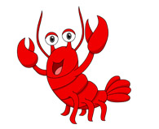
Then circle your answer.
1. Have you ?
a.Yes I have. b.No I haven’t

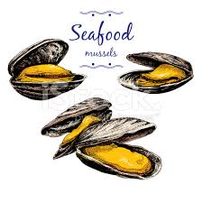
2.

a.Yes I have. b.No I haven’t

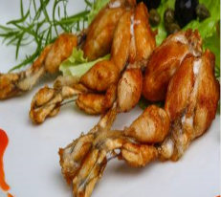
3

a.Yes I have. b.No I haven’t

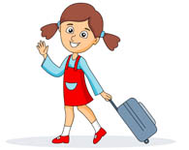
4.

a.Yes I have. b.No I haven’t

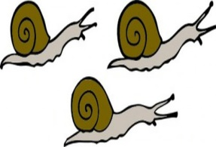
5.

a.Yes I have. b.No I haven’t

1.(catch) a lobster 2.(eat)mussels 3.(cook)frog legs 4.(go) to the airport 5. (eat) snails

