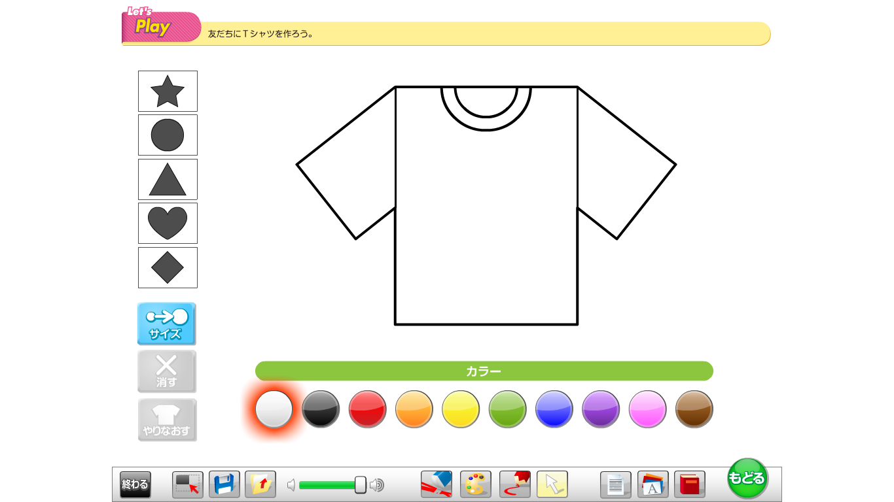

*カラー*

*I like ~ and ~.*

*What ~ do you like?*

*From: ____________*

*What ~ do you like?*

*From: _________________*



*カラー*

*From: _________________*

*What ~ do you like?*

*I like ~ and ~.*

*I like ~ and ~.*

*What ~ do you like?*

*From: _________________*

*カラー*

*I like ~ and ~.*

*カラー*