Australia – culture class
Name ( ) Class ( ) No ( )
Learn more about the land down under!
1. Basic info | 2. Aboriginal  - Australian Aboriginal culture is the OLDEST in the world.  - They are spiritual people.  - There are many tribes (部族) and languages.  - Famous for art. Aboriginal “dot” art.  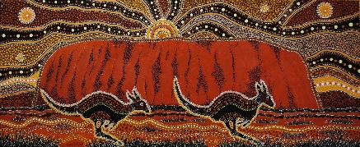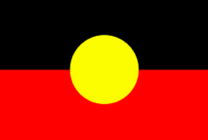
3. Uluru  1. It is a spiritual place  2. It is 348m tall.  3. Do not climb!  4. The Anangu lived there for more than 30,000 years.  5. It is about 600 million years old. (6億)  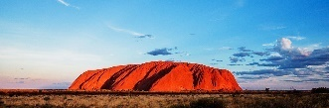 | 4. Nature in Australia (Places)  Q1: How many UNESCO world heritage sites are there in Australia?  They include: ① the Great Barrier Reef, ② the Sydney Opera House, ③ the Tasmanian Wilderness and ④ Purnululu National Park.  Q2: How many years is it to visit every beach?
5. Nature in Australia (Animals)  Q2: What are the national animals of Australia? (choose two) (国の動物)  - Steve Irwin was a TV personality. He was interested in crocodiles. He had a TV show called “the Crocodile Hunter”.  Q1: How many species of spiders are there in Australia? ____________________________  (クモの種) | 6. Australian Food and Drink  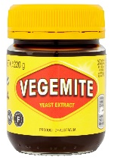  Foods: lamington, Tim Tams, Vegemite and avo toast.  Q1: What is it?  ___________________ bread.  Q2: What is the unique hamburger topping?  Q3: We can eat kangaroo meat.  ( ○ / ✘ )
7. Aussie English  Australians have very unique slang. Let’s learn!  1. G’day mate ___________ 2. Avo ___________ 3. Brekky ___________  4. Chook ___________ 5. Maccas ___________ 6. Sheila ___________  7. Snag __________ 8. Lollies ___________ 9. Bruce ___________ | 8. Random Australia  Q1: What Sport is Australia best at in the Olympics?  Q2: Are there “pink” lakes (湖) in Australia?  ( ○ / ✘ )  - Over 300 languages are spoken in Australia  - A man in New Zealand tried to sell Australia on eBay.
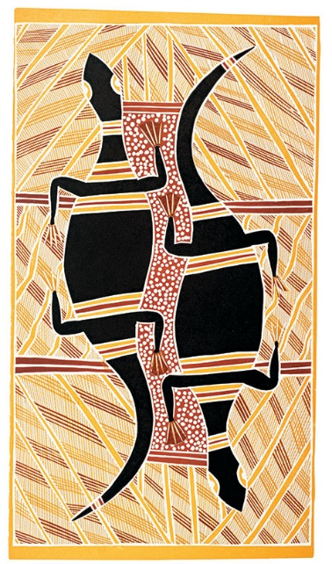
Summary
Step 1: Understanding today’s information
★ Winner asks:
1. How many people are living in Australia? (Check 1. Basic info)
2. How many UNESCO world heritage sites are there? (Check 4. Nature in Australia)
3. Tell me 3 “Aussie” English words. (Check 7. Aussie English)

★ Loser asks:
1. Can you eat kangaroo meat? (Check 6. Aussie Food and Drink)
2. What are the national animals of Australia? (Check 5. Nature in Australia)
3. What language do they speak in Australia? (Check Basic info)

Step 2: Please write about what you have learnt in this class. 日本語 or English

Name ( ) Class ( ) No ( )
USE English! HINT quiz

How much do you know about the world? Here are some simple facts about
Some countries. Can you guess them?

Today’s point: Test your geography in English. Can you catch all meanings?

Question 1:
Hint 1: 3 points | Hint 2: 2 points | Hint 3: 1 point
______________ | ______________ | ______________

Question 2:
Hint 1: 3 points | Hint 2: 2 points | Hint 3: 1 point
______________ | ______________ | ______________

Question 3:
Hint 1: 3 points | Hint 2: 2 points | Hint 3: 1 point
______________ | ______________ | ______________

Question 4:
Hint 1: 3 points | Hint 2: 2 points | Hint 3: 1 point
______________ | ______________ | ______________

Question 5:
Hint 1: 3 points | Hint 2: 2 points | Hint 3: 1 point
______________ | ______________ | ______________
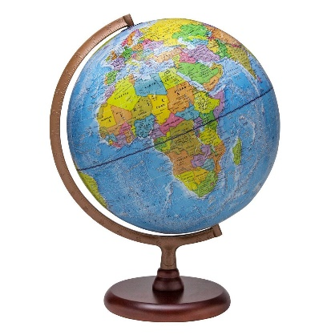
I got __________________ out of 15.

Name ( ) Class ( ) No ( )

