Name: Date:

Too
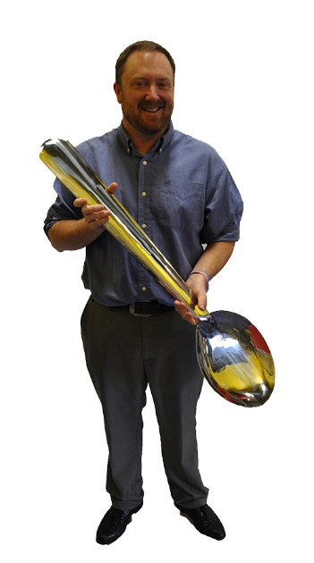

This coat is too expensive.
Do you have a cheaper one? ________________________ _____________________________
________________________ _____________________________

 

