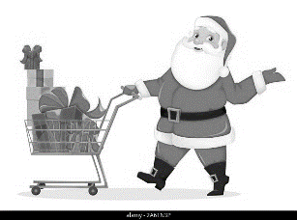
Christmas Shopping
A: Clerk | B: Customer
A: Hello. May I help you?
 | B: Yes, please. I’m looking for a ________.
A: Okay, we have some here.  What (color/size) are you looking for? | B: Something ______ (in a _____ size) please.  dark/light + color  small, medium, large
A: How about this one? | B: Oh, that’s ___________. How much is it?  nice, cute, cool, perfect
A: It’s ________ dollars. | Bargaining!
That’s too expensive! | 高い過ぎる！ | Can you give me a discount? | 安くしてもらえませんか？
That’s too cheap! | 安すぎる！ | How about $__? | __ドルではどうですか？
That’s a scam! | それは詐欺だ！ | Deal! | 決めた！

When I was a customer, I bought (a) (item) for (price) from (clerk’s name).
 | Item | Bought? | Price | Clerk’s name
例 | green sweater | O | $45 | Satoshi
1
2
3
4
5
6

(D)

(C)

Totals:
Totals:
(B)

(A)
When I was a clerk, I sold (a) (item) for (price) to (customer’s name).
 | Item | Sold? | Price | Customer’s name
例 | baseball bat | X | X | Nobita
1
2
3
4
5
6

