What do you usually _____ for _______?

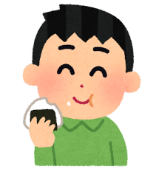 | 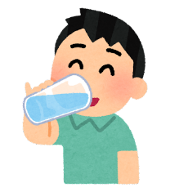 | 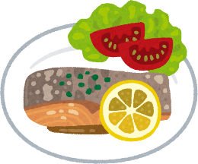 | 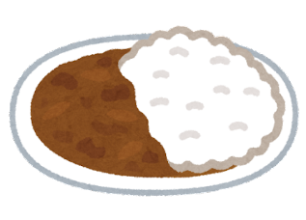
eat | drink | breakfast | dinner

Name | eat for breakfast | drink for breakfast
Name | eat for dinner | drink for dinner

