Hi, how are you?

I’m fine, thanks, and you?

I’m good, thanks.

Let’s eat sushi.

I don’t like sushi.

Ok. What food do you like?

I like pizza.

Me, too. Let’s eat pizza!

Great. Let’s play soccer!

Okay! I like soccer.

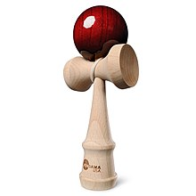
Great. Let’s go!

