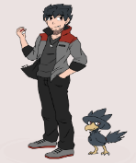
Name: ____________ Class: ____ Number: ____ Date: __/___

- __________________________________________________________
- __________________________________________________________
- __________________________________________________________
- __________________________________________________________
- __________________________________________________________
- __________________________________________________________
- __________________________________________________________
- __________________________________________________________
- __________________________________________________________
- __________________________________________________________
- __________________________________________________________
- __________________________________________________________
PICTURE STORIES





