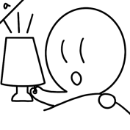  turn on the light | 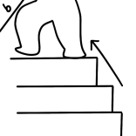  go upstairs | 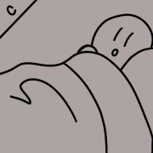  wake up
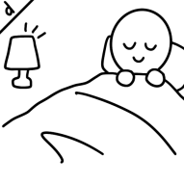  get into bed | 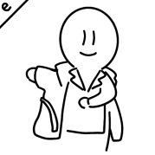  take off his robe | 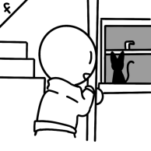  open the door
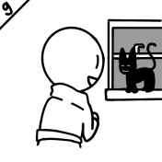  see a cat outside the window | 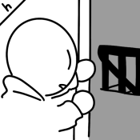  open the bedroom door | 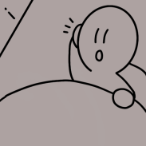  hear a noise
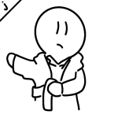  put on his robe | 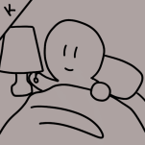  turn off the light | 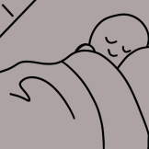  go to sleep
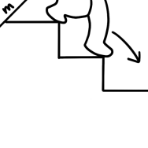  go downstairs | 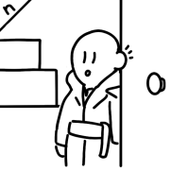  listen at the door | 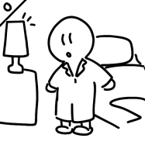  get out of bed
Cからスタートです。このように記号と英文(過去形にして)を書き、順番に並べていきましょう！

- (C) He woke up._____________________________
- ( I ) He heard a noise._________________________
- (A ) He turned on the light._____________________
- ( O ) He got out of bed._______________________
- ( J ) He put on his robe.______________________
- ( H ) He opened the bedroom door._______________
- ( M ) He went downstairs.______________________
- ( N ) He listened at the door. ___________________
- ( F ) He opened the door.._____________________
- ( G ) He saw a cat outside the window.___________
- ( B ) He went upstairs.._______________________
- ( E ) He took off his robe._____________________
- ( D ) He got into bed.___________________
- ( K) He turned off the light.__________________
- (L) He went to sleep.____________________
•turn→turned •go→went •wake up→woke up •get→got take→took •open→opened •see→saw •hear→heard •put→put •listen→listened

turn on the light | go upstairs | wake up
get into bed | take off his robe | open the door
see a cat outside the window | open the bedroom door | hear a noise
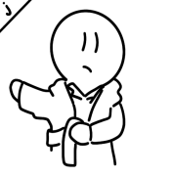  put on his robe | 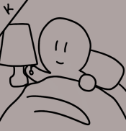  turn off the light | 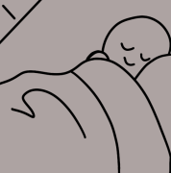  go to sleep
go downstairs | listen at the door | get out of bed
Cからスタートです。このように記号と英文(過去形にして)を書き、順番に並べていきましょう！

- (C) He woke up._____________________________
- ( ) ___________________________________
- ( ) ___________________________________
- ( O ) He got out of bed.______________________
- ( J ) He put on his robe.______________________
- ( ) ___________________________________
- ( M ) He went downstairs._____________________
- ( ) ___________________________________
- ( F ) He opened the door._____________________
- ( ) ___________________________________
- ( ) ___________________________________
- ( E ) He took off his robe.____________________
- ( ) ___________________________________
- ( K ) He turned off the light.__________________
- ( ) ___________________________________

•turn→turned •go→went •wake up→woke up
•get→got take→took •open→opened •see→saw •hear→heard
•put→put •listen→listened

