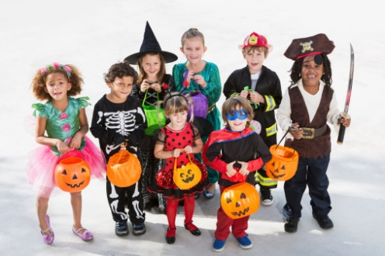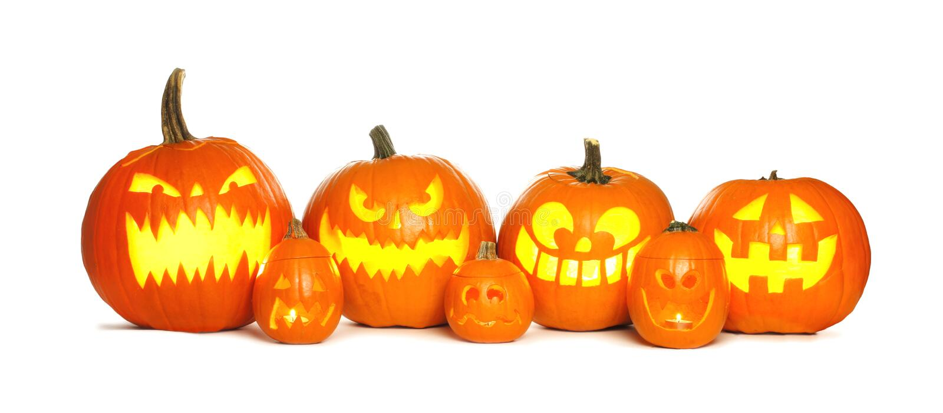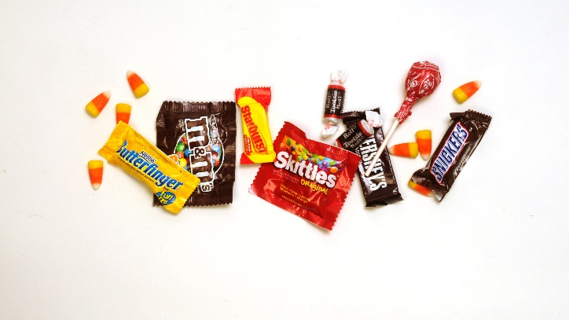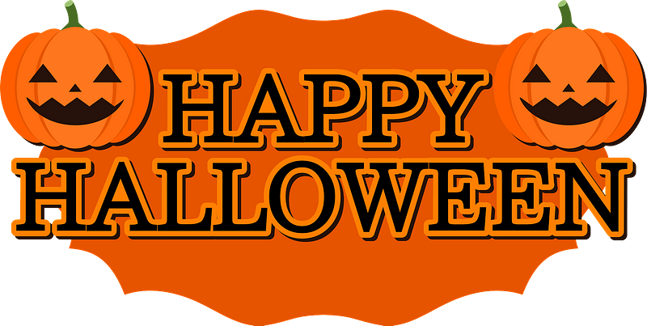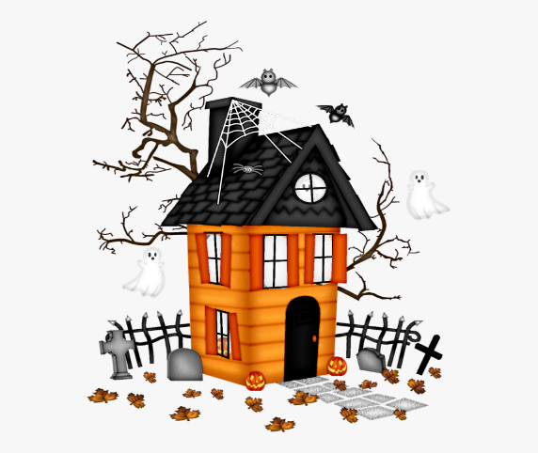

Do you know what October 31st is?

There are many ways to celebrate – watching scary movies, dressing up, eating candy, and so on. How will you celebrate Halloween?

In the US, kids dress up as their favorite characters and get candy!

Adults also dress up and go to parties.

They are called “jack-o-lanterns”

Trick or treat!

Halloween is a time for scary things. People decorate their houses with spiders, ghosts, and pumpkins with scary faces.

It`s...