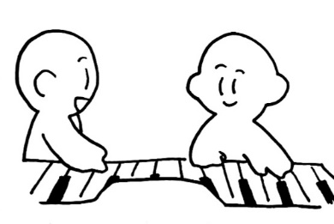
Indirect Questions

Example: Q: I don’t know why they are happy.
A: They are happy because they are playing the piano.

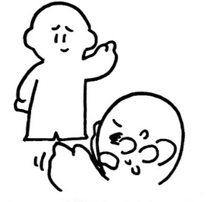
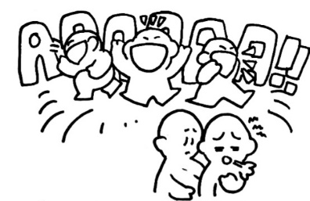
1. 4.

Q: I don’t know why he is ______________. Q: I don’t know why she is ______________.
A: He is __________ because _____________________. A: She is __________ because ____________________.
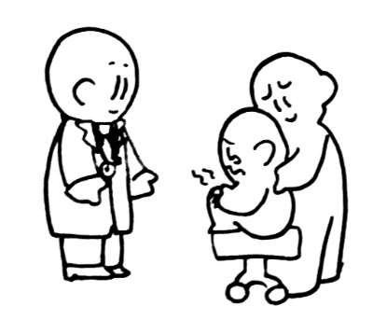
2. 5.

Q: I don’t know why he is ______________. Q: I don’t know why he is ______________.
A: He is __________ because _____________________. A: He is __________ because ______________________.

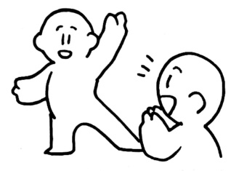
3.

Word Ideas
happy worried bored
sad excited angry
scared tired surprised

Q: I don’t know why she is ______________.
A: She is __________ because _______________________.

