Student A: ‘There are 2 bookstores.’
Name: _______________
Student B: ‘There is a bookstore.
Student A/Student B: ‘1, 2, 3’ (Janken)
Places | Number
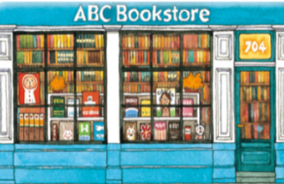
a bookstore
bookstores
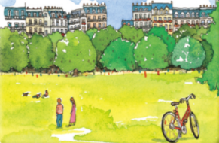
a park
parks
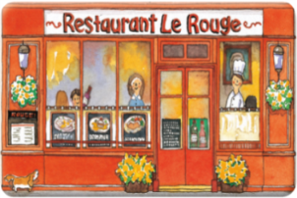
a restaurant
restaurants
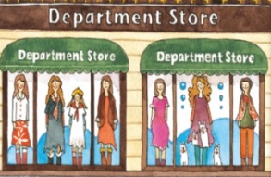
a department store
department stores
How many interesting places are there in your town?
There are ______ interesting places in my town.
Writing Practice
- ________________________________________________
- ________________________________________________
- ________________________________________________
- ________________________________________________

