Name: ____________ Class: ____ Number: ____ Date: ___ / ____

- _________________________________________________________
_________________________________________________________
- _________________________________________________________
_________________________________________________________
- _________________________________________________________
- _________________________________________________________
- _________________________________________________________
_________________________________________________________
- _________________________________________________________
- _________________________________________________________
_________________________________________________________
- _________________________________________________________
- _________________________________________________________
- ______________________________________________________
- ___________________________________________
___________________________________________
- ________________________________________
___________________________________________
- ________________________________________
___________________________________________________________
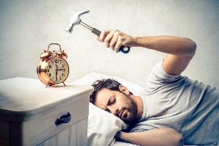
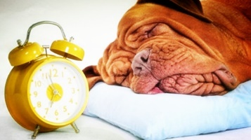
Jenny
7:00am
Stan
6:15am
John
6:00am

- _____________________________________________________
________________________________________________________
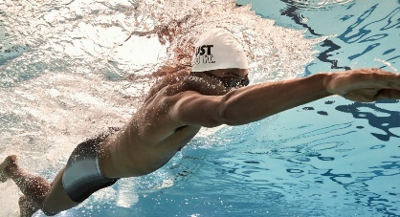
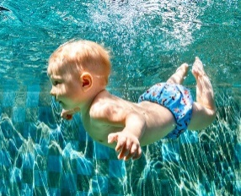
Mei
6kph
Eric
7kph
Mike
1kph

- _____________________________________________________
________________________________________________________
- ______________________________________________________
_________________________________________________________
- ______________________________________________________
_________________________________________________________
- ______________________________________________________
_________________________________________________________
- ______________________________________________________
_________________________________________________________
- ______________________________________________________
_________________________________________________________
- ______________________________________________________
_________________________________________________________

- Who has the most beautiful voice in Japan? What song do you like?
- What is the most exciting season in Japan? Why?
- What is as beautiful as a flower?
- Who studies the hardest in your group?
- What are the cutest animals in the world? Why?
- What isn’t as important as family?
- Which are more interesting, games or movies? Why?
- What is taller than Tokyo Tower?
- What moves faster than a car?
5. Who draws the best?

How many stars? ______

Answer: ______________________________________________________

- What is the most difficult subject?
5. Who draws the best?

How many stars? ______

Answer: ______________________________________________________

- Who draws cats the best in your group? (show me the picture)
5. Who draws the best?

How many stars? ______

Answer: ______________________________________________________

- Who writes kanji the nicest in your group? (show me the kanji)
5. Who draws the best?

How many stars? ______

Answer: ______________________________________________________

- What prefecture has the most delicious food? What food? Prefecture = 県
5. Who draws the best?

How many stars? ______

Answer: ______________________________________________________

- Write about the pictures. (2 sentences)
- Write about the pictures. (2 sentences)
- What do you like better than school? What do you like the best?
- What is the most dangerous season? Why?
- What do you like as much as sushi? Why?
- Who goes to bed the latest in your group? What do they do at night?
- What is the longest river in Japan? Where is it?
- What subject do you like the best? Why?

