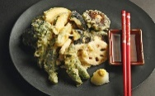
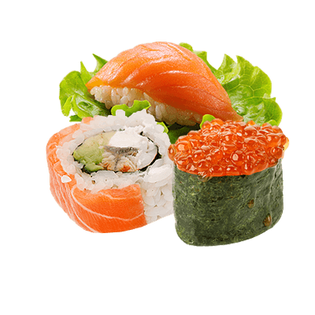
Which do you like, SUSHI or TEMPURA?
Can you guess which one? Let’s TRY!
Teacher | Question | Guess | POINT
[teacher 1] | - Which do you like,  sushi or tempura?
- Which do you like,
the mountain or the sea?
- Which do you like,
Spanish or English?
- Which do you like,
dramas or comedies?
- Which do you want,
money or a holiday?
- Which do you want,
pizza or spaghetti?
[teacher 2] | - Which do you like,  soba or udon?
- Which do you like,
Osaka or Tokyo?
- Which do you like,
frogs or dogs?
- Which do you like,
apples or oranges?
5. Which do you want,
money or a holiday?
6. Which do you want,
sandwiches or rice balls?
I got ______________________ points out of 12!

Question time! (※I like both.) = OK
Question | I like: | My partner likes:
1. Which do you like, cats or dogs?
2. Which do you like, meat or fish?
3. Which do you like, bread or rice?
4. Which do you like, English or science?
- Which do you like, games or homework?
- Which do you like, ________ or ________?
Name ( ) Class ( ) No ( )

