Name: ______________ Class: ___ Number: ___ Date: ___/___
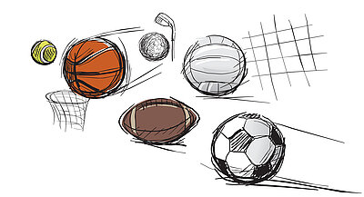
BALLS QUIZ
GAME
- _________________________________________________________________
- _________________________________________________________________
- _________________________________________________________________
- _________________________________________________________________
- _________________________________________________________________
- _________________________________________________________________
- _________________________________________________________________
- _________________________________________________________________
- _________________________________________________________________
- _________________________________________________________________
- _________________________________________________________________
- _________________________________________________________________
WRITING TIME
- What is the most beautiful season in Japan?
_________________________________________________________________
_________________________________________________________________
_________________________________________________________________
- What are used by students at school?
_________________________________________________________________
_________________________________________________________________
_________________________________________________________________
- What do you want to do next year?
_________________________________________________________________
_________________________________________________________________
_________________________________________________________________
- What do you have to do at home?
_________________________________________________________________
_________________________________________________________________
_________________________________________________________________
- What animals are seen in this area?
_________________________________________________________________
_________________________________________________________________
_________________________________________________________________
- What food is made in your home town?
_________________________________________________________________
_________________________________________________________________
_________________________________________________________________
- Where have you been this year?
_________________________________________________________________
_________________________________________________________________
_________________________________________________________________
- What do you do in your free time? How long have you enjoyed it?
_________________________________________________________________
_________________________________________________________________
_________________________________________________________________
- What must you not do at home?
_________________________________________________________________
_________________________________________________________________
_________________________________________________________________
- What is the best place to visit in Niigata?
_________________________________________________________________
_________________________________________________________________
_________________________________________________________________
QUESTIONS FOR QUIZ GAME
例. What was built in 1964?
- How many times have you been to Tokyo?
- Have you ever been to China?
- How long has Nishikori played tennis?
- What do you have to do at home?
- What must you not do at school?
- What does she want to be?
- Where are curry and nan eaten?
- When was Robert born?
- Who is chalk used by?
- What are bigger than dogs?
- What is the longest river in Japan?
- What is more important than school?

