Name: ________________ Class: ____ Number: ____ Date: __/___

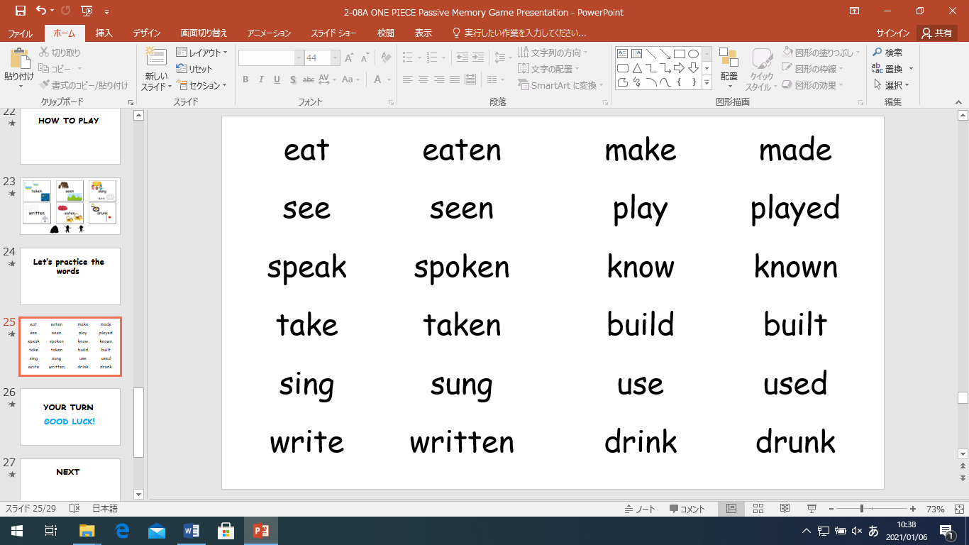



**WRITING PRACTICE**

**[](https://2.bp.blogspot.com/-HcYwPkNFxJY/U2tHgvzDD6I/AAAAAAAAgOc/AVd1W_9E1xo/s800/Japan.png)**

1. ****______________________________________________________



tests

1. ______________________________________________________



1. ______________________________________________________

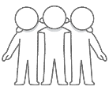

1. ______________________________________________________

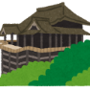

1. 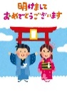______________________________________________________



1. ______________________________________________________
2. _____________________________________________
3. _____________________________________________