Name: 4 - _____

Hi! My name is I`m from
______________________
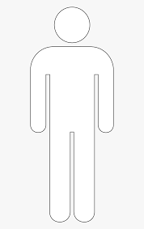
______________________ ________________.

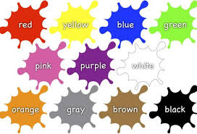
I like ___________________.

I have a

_________________.

