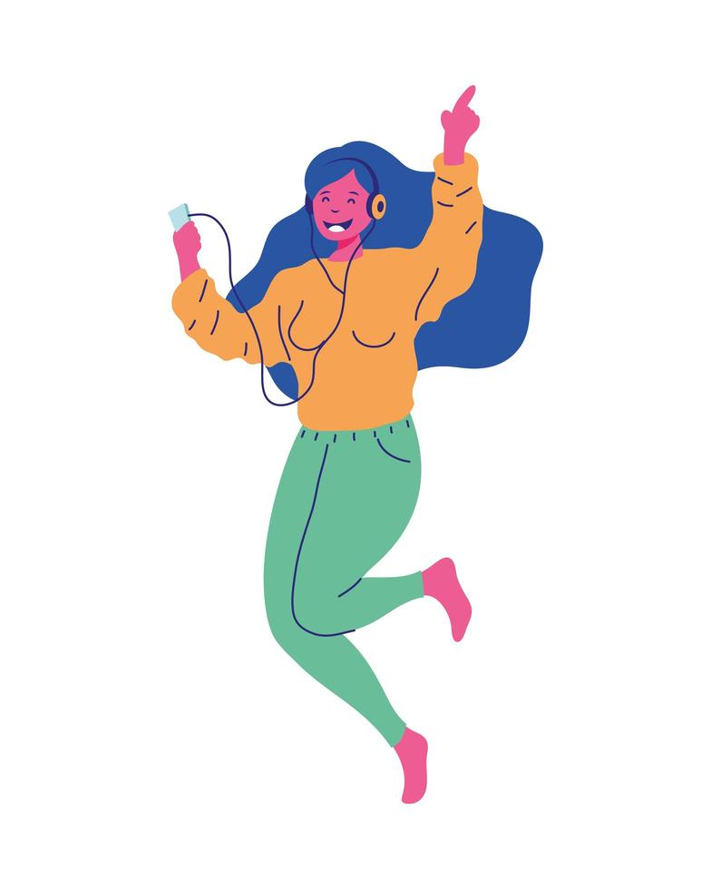
Listen to me! ①「Bastille – Pompeii」
Eh, eheu, eheu x8
I was left to my own devices
Many days fell away with nothing to (➀ s )
And the walls kept tumbling down in the city that we love
Grey clouds roll over the hills, bringing darkness from (➁ a )
Listen to the whole song and fill in the blanks. Let’s enjoy listening to music!
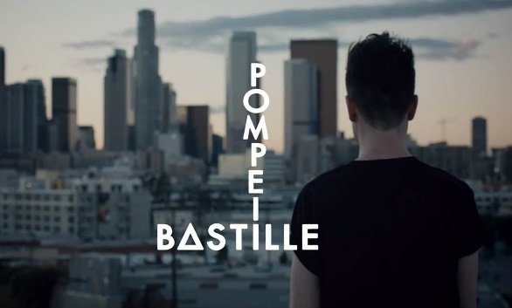
But if you close your eyes
Does it almost feel like nothing changed at (➂ a )?
And if you close your eyes
Does it almost feel like you've been here (➃ b )?
How am I going to be an optimist about this?
How am I going to be an optimist about this?
We were caught up and lost in all of our vices
In your pose as the dust settled around (➄ u )
And the walls kept tumbling down in the city that we love
Grey clouds roll over the hills, bringing darkness from above
But if you close your (➅ e )
Does it almost feel like (➆ n ) changed at all?
And if you close your eyes
Does it almost feel like you've been here before?
How am I going to be an optimist about this?
- 気になる言葉:
__________________________________
__________________________________
__________________________________
__________________________________

MEMO!
How am I going to be an optimist about this?
Oh, where do we (➇ b ), the rubble or our sins?
Oh, where do we (➈ b ), the rubble or our sins?
And the walls kept tumbling down in the (⑩ c ) that we love (Oh, where do we begin, the rubble or our sins?)
Grey clouds roll over the hills bringing darkness from above (Oh, where do we begin, the rubble or our sins?)
But if you (⑪ c ) your eyes
Does it almost feel like nothing changed at all?
(⑫ A ) if you close your eyes
Does it almost feel like you've been here (⑬ b )?
How am I going to be an optimist about this?
How am I going to be an optimist about this?
If you close your (⑭ e )
Does it almost feel like nothing changed at (⑮ a )?
I got ______ out of 15!
Eh, eheu, eheu x8
Name ( ) Class ( ) No ( )
Listen to me! ①「Bastille – Pompeii」
Eh, eheu, eheu x8
I was left to my own devices
Many days fell away with nothing to show
And the walls kept tumbling down in the city that we love
Grey clouds roll over the hills, bringing darkness from above
Listen to the whole song and fill in the blanks. Let’s enjoy listening to music!
But if you close your eyes
Does it almost feel like nothing changed at all?
And if you close your eyes
Does it almost feel like you've been here before?
How am I going to be an optimist about this?
How am I going to be an optimist about this?
We were caught up and lost in all of our vices
In your pose as the dust settled around us
And the walls kept tumbling down in the city that we love
Grey clouds roll over the hills, bringing darkness from above
But if you close your eyes
Does it almost feel like nothing changed at all?
And if you close your eyes
Does it almost feel like you've been here before?
How am I going to be an optimist about this?
- 気になる言葉:
__________________________________
__________________________________
__________________________________
__________________________________

MEMO!
How am I going to be an optimist about this?
Oh, where do we begin, the rubble or our sins?
Oh, where do we begin, the rubble or our sins?
And the walls kept tumbling down in the city that we love (Oh, where do we begin, the rubble or our sins?)
Grey clouds roll over the hills bringing darkness from above (Oh, where do we begin, the rubble or our sins?)
But if you close your eyes
Does it almost feel like nothing changed at all?
And if you close your eyes
Does it almost feel like you've been here before?
How am I going to be an optimist about this?
How am I going to be an optimist about this?
If you close your eyes
Does it almost feel like nothing changed at all?
I got ______ out of 15!
Eh, eheu, eheu x8
Bastille – Pompeii 和訳

自分の好きなように生きてきた
いくつもの日々が特に何もなく過ぎた
すると僕らの愛する街の壁が崩れ落ちていった
灰色の雲が丘に広がり、天から暗闇を連れてくる
でももし君が目を閉じたら
ほとんど何も変わってない気がしないか？
もし君が目を閉じたら
ほとんどここへ来る前と同じ気がしないか？
?
どうしてこの状況で楽天家になろうとするのだろう？
どうしてこの状況で楽天家になろうとするのだろう？

僕たちは自らの悪行に捕らわれ、失った
あたりの混乱は収まったかのような君の姿
すると僕らの愛する街の壁が崩れ落ちていった
灰色の雲が丘に広がり、天から暗闇を連れてくる
どこから手をつけよう？瓦礫、それとも私たちの過ち？
どこから手をつけよう？瓦礫、それとも私たちの過ち？

すると僕らの愛する街の壁が崩れ落ちていった
灰色の雲が丘に広がり、天から暗闇を連れてくる
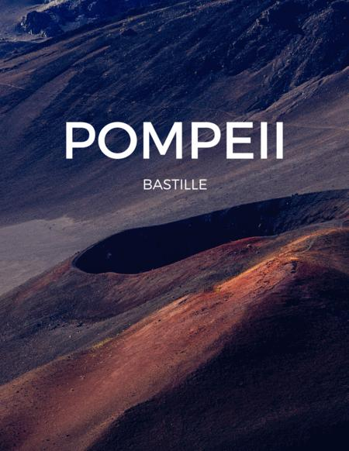
でももし君が目を閉じたら
ほとんど何も変わってない気がしないか？
もし君が目を閉じたら
ほとんどここへ来る前と同じ気がしないか？

どうしてこの状況で楽天家になろうとするのだろう？
どうしてこの状況で楽天家になろうとするのだろう？
もし君が目を閉じたら
ほとんど何も変わってない気がしないか？

