Name: Class: Number:

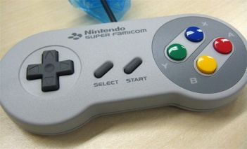
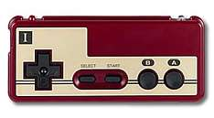
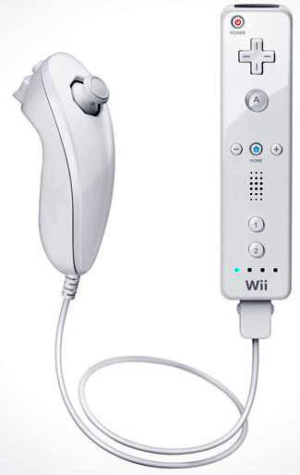
I have played Nintendo for about 25 years .
3A

Step 1. Finish the sentences.

- I have lived in YOUR TOWN for years.
- I have studied English for years.
- I have been a 3rd year student for months.
- I have ridden a bicycle for years.
- I have had my shoes for .
- I have played for .

Step 2: Write new sentences. Example: I have played Biohazard for 7 years .
used a computer played games played Nintendo
played the piano eaten natto curry
studied English been an Arashi fan had a dog
been a volleyball player had my shoes

Step 3: write 1 LIE (1つのうそをつく) example: I have had a rabbit for 2 years .

Name
うそはどちら：

1.
<ALT>
A B C D
2.

A B C D
3.

A B C D
4.

A B C D
5.

A B C D
6.

A B C D
7.

A B C D
8.

A B C D
9.

A B C D
10.

A B C D
11.

A B C D

