**Replying to a voice mail** (p. 45)

Step 1: Make a Draft!

Name: __________________ Class: ___

1.:



About Our Meetup (一緒にお出かけ)

About __________________’s Birthday Party

Other (その他): About __________________________

x1

About Our Trip to _______________________________

About Our Gaming Party (ゲーム会)



x1

2. who?

/ / ___________________

Other (その他): ____________________________________

My friend: ___________________________________

/ Hirano Sho / ____________________



電話に出られなかった理由

x1

I’m sorry that I missed your phone call, ______________________________________________________________   
 I was busy doing something. (色々していて忙しかった。)  
 my phone died. (携帯の電池がなくなちゃった。)  
 I was ~ing. 🡪 I was ___________________________________________________.  
[例] I was cook**ing** dinner. | I was sleep**ing**.

3. :



【】Yes, I’m free (on) __________________________________.

【必須】How about we meet at (the) ____________________________ at _________________________?

Should I bring _______________________________________?　(_____を持っきたほうがいいの？)

I will get there by ________________________________________. (_____で行く予定です。)

Will you __________________________________? または I will ______________________________________.

Are you going to _____________________________? または I’m going to ______________________________.

Other (その他): ___________________________________________________________________________________

x1

曜日・日付・など

4. : (感想、伝えたいことなど)

会う時間

場所

持ってくるもの

乗り物

5. :



x1

I can’t wait to see you. (早く会いたいな)  
 I’m looking forward to ______________________________________________________.   
 message me back when you are free.  
 don’t be late! (遅れないでね！)



x1

6. :

gnite

ily

Take care,

ttyl

cya (soon)

Pencil Clip Art at Clker.com - vector clip art online, royalty free &amp;  public domain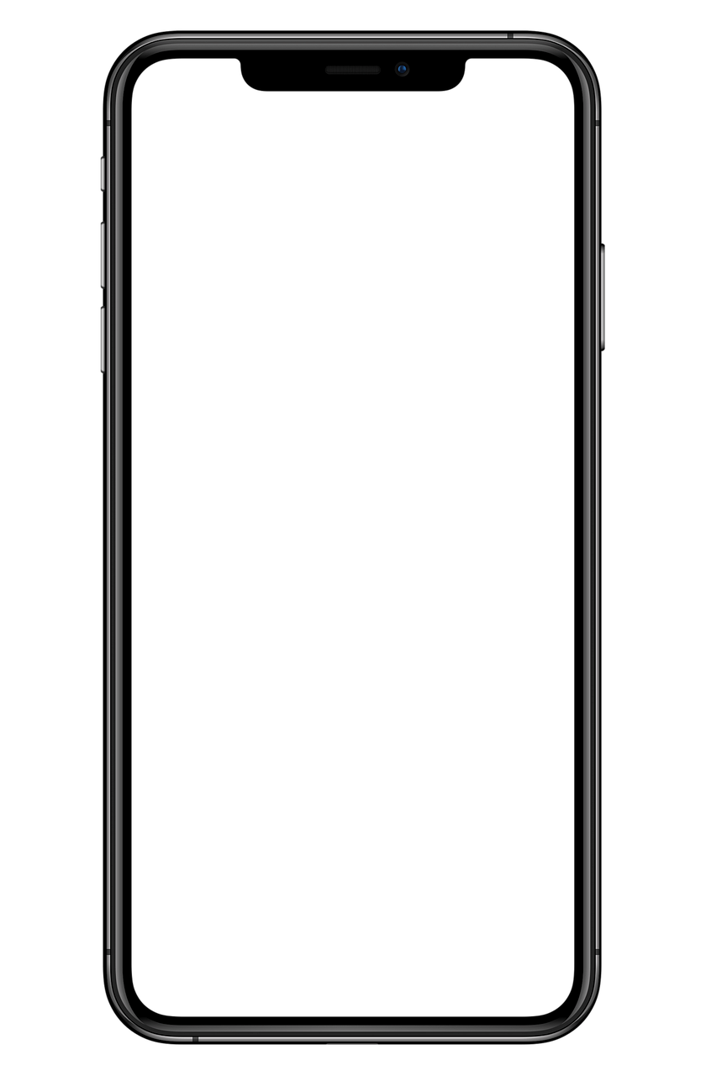Pencil Clip Art at Clker.com - vector clip art online, royalty free &amp;  public domain

Create your own original emoji!

署名

5. まとめ（結び）

6. 終わりのあいさつ

(任意) 追加情報・他の伝えたいこと・質問・など

Hi, _______________________.

**I’m|sorry|I|missed|your|phone|call,||||||||||||||||||||||||||||||**

**|||||||||||||||||||||||||||||||||||||||||||||||||||||||||||||||||||||||||||||||.**

**Yes,|I’m|free|||||||||||||||||||||||||||||||||||||||||||||||||||||||||||||.**

**Let’s|meet|at||||||||||||||||||||||||||||||||||at|||||||||||||||||||||||.**

Is that okay?

|||||||||||||||||||||||||||||||||||||||||||||||||||||||||||||||||||||||||||||||||||||

|||||||||||||||||||||||||||||||||||||||||||||||||||||||||||||||||||||||||||||||||||||

|||||||||||||||||||||||||||||||||||||||||||||||||||||||||||||||||||||||||||||||||||||

Anyway, |||||||||||||||||||||||||||||||||||||||||||||||||||||||||||||||||||||||

||||||||||||||||||||||||||||||||||||||,  
  
__________________

4. 内容（感想、伝えたいことなど）

電話に出られなかった理由

:) 笑顔　　 ;) 瞬き；ウインク  
:( 悲しい :O 驚いた  
:D 嬉しい :| 無感情  
:P 舌を出す >:( 怒ってる  
xD 笑ってる <3 ♡

ASAP = なるべく早く ty = ありがとう  
btw = ところで tyvm = 本当にありがとう   
lol / LOL = 笑 np = 問題ない；とんでもない   
looool = しぬｗｗｗ omg = oh my god   
y = why 　 soz = ごめん  
ur = your pls / plz = please  
r u = are you w/ = with

3. 導入

2. 誰に？

1. : _______________________________________________________

EMOJI (絵文字)

ACRONYMS (略語)

To: myfriendisverycool@yawho.jp.xyz