Name: Class:

Listen to the song. Circle the correct word for each sentence from the song.

For the First Time in Forever

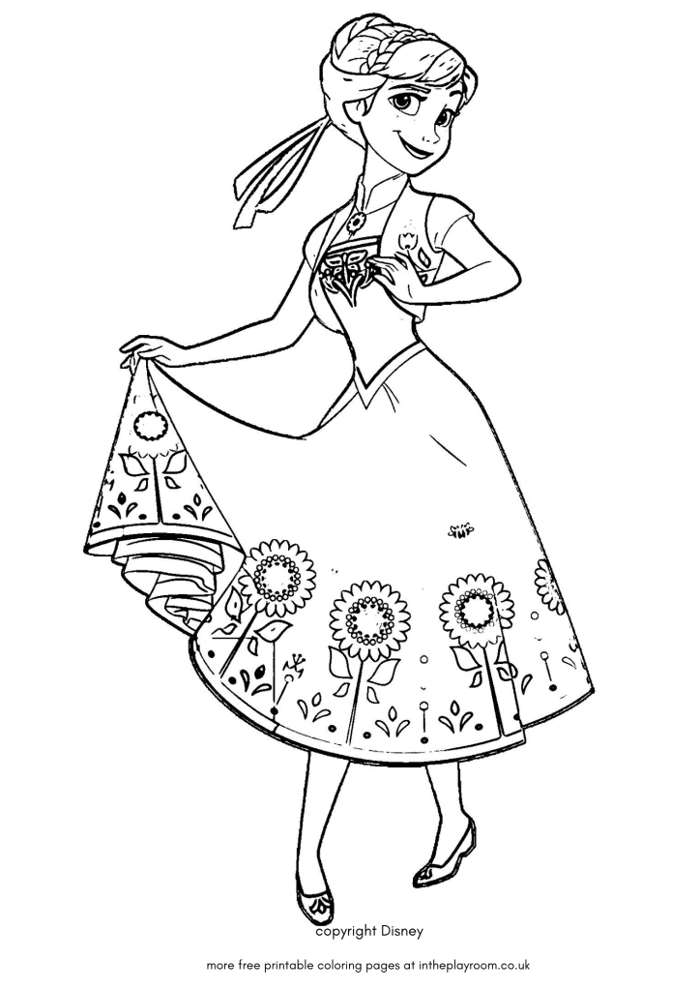
The window is ( closed / open ), so’s that door
I didn’t know they did that anymore
Who knew we owned eight thousand salad plates?
For ( days / years ) I’ve roamed these empty halls
Why have a ballroom with no balls?
Finally ( these / they’re ) opening up the gates

There’ll be actual real live ( places / people )
It’ll be totally strange
But wow, ( am / was ) I so ready for this change?

‘Cause for the first ( take / time ) in forever
There’ll be ( music / magic ), there’ll be light
For the first time in forever
( We’ll / I’ll ) be dancing through the night

Don’t know if I’m elated or gassy
But ( I’m / I’ll ) somewhere in that zone
‘Cause for the ( first / last ) time in forever
I won’t be alone

I ( can’t / won’t ) wait to meet everyone!
What if I ( meet / met ) the one?

