NAME:
Class
Number
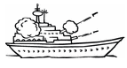
Let’s practice using Does/Doesn’t!

---------------------------------------------------------------------------------------------------------------------------------------------------------

Q. Does Takeru play baseball? A. Yes, he does. = O / No, he doesn’t. = X
Q. Does Nene sing enka? A. Yes, she does. =O / No, she doesn`t. = X
FRIEND’S game board

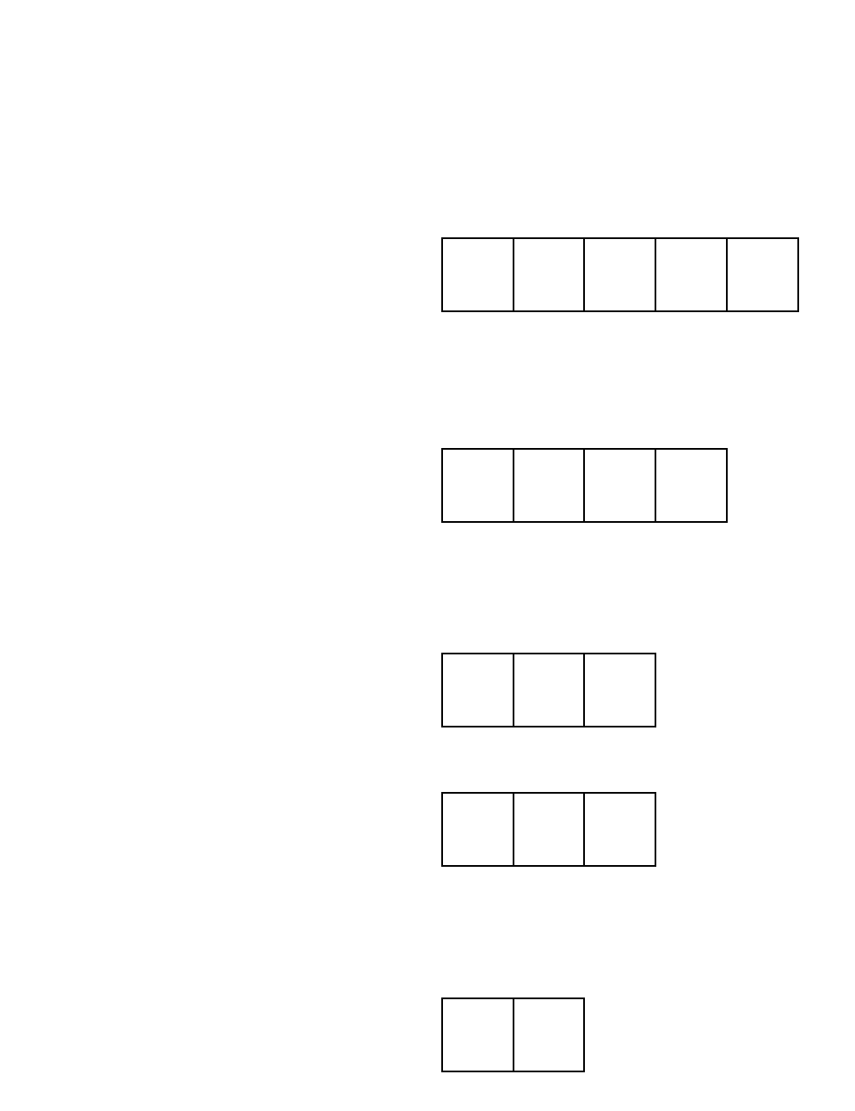
Does  Miku | Does  Kevin | Does  Bob | Does  Rina | Does  Becky | Does  Nene | Does  Takeru
 |  |  |  |  |  |  | … play baseball?
 |  |  |  |  |  |  | … eat sushi?
 |  |  |  |  |  |  | … sing enka?
 |  |  |  |  |  |  | … like natto?
 |  |  |  |  |  |  | … love Pamyu-Pamyu?
 |  |  |  |  |  |  | … read Harry Potter?
 |  |  |  |  |  |  | … cook dinner every day?

FIVE ships each:

1 x (Aircraft carrier)
1 x (Battleship)
2 x (Cruiser and Submarine)
1 x (Destroyer)

---------------------------------------------------------------------------------------------------------------------------------------------------------
YOUR game board

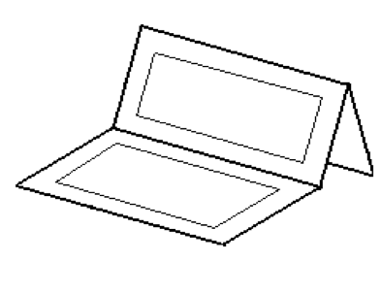
Does  Miku | Does  Kevin | Does  Bob | Does  Rina | Does  Becky | Does  Nene | Does  Takeru
 |  |  |  |  |  |  | … play baseball?
 |  |  |  |  |  |  | … eat sushi?
 |  |  |  |  |  |  | … sing enka?
 |  |  |  |  |  |  | … like natto?
 |  |  |  |  |  |  | … love Pamyu-Pamyu?
 |  |  |  |  |  |  | … read Harry Potter?
… cook dinner every
day?

O = HIT
X = MISS
-Draw your five ships on YOUR game board.
Don’t let your partner see!
-Use your PARTNER’S game board to mark your guesses.
-If your partner hits every square of one ship, you must say “You sank my ship!”
-If your partner sinks all of your ships, you
LOSE!
Please fold your paper like this.

