Name: Class:

Listen to the song. Circle the correct word for each sentence from the song.

Part of Your World

I wanna ( be / is ) where the people are
I wanna ( hear / see ), wanna see ‘em dancin’
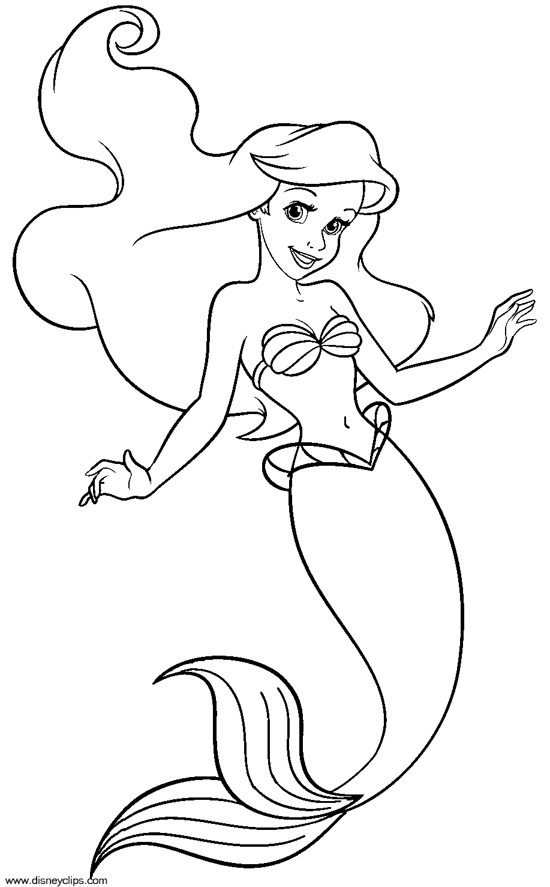
Walking around on those, what ( does / do ) you call ‘em?
Oh, feet

Flippin’ your fins, you ( doesn’t / don’t ) get too far
Legs ( is / are ) required for jumping, dancing
Strolling along down the, what’s that word again?
Street

Up where they walk, up where they run
Up where they ( stay / play ) all day in the sun
Wanderin’ free, wish I could be
Part of that world

What would I ( give / swim ) if I could live out of these waters?
What would I ( say / pay ) to spend a day warm on the sand?
Bet’cha on land, they understand
Bet they ( don’t / doesn’t ) reprimand their daughters
Bright young women, sick of swimmin’
Ready to stand

And ready to ( think / know ) what the people know
Ask ‘em my questions and ( give / get ) some answers
What’s a fire and why ( do / does ) it, what’s the word?
Burn?

When’s it my turn?
Wouldn’t I love, love to ( enjoy / explore ) that shore up above?
Out of the sea
Wish I could be
Part of that world

