Let’s Listen to the Weather Forecast!
Exercise 1
Draw a line to match the pictures with the word.
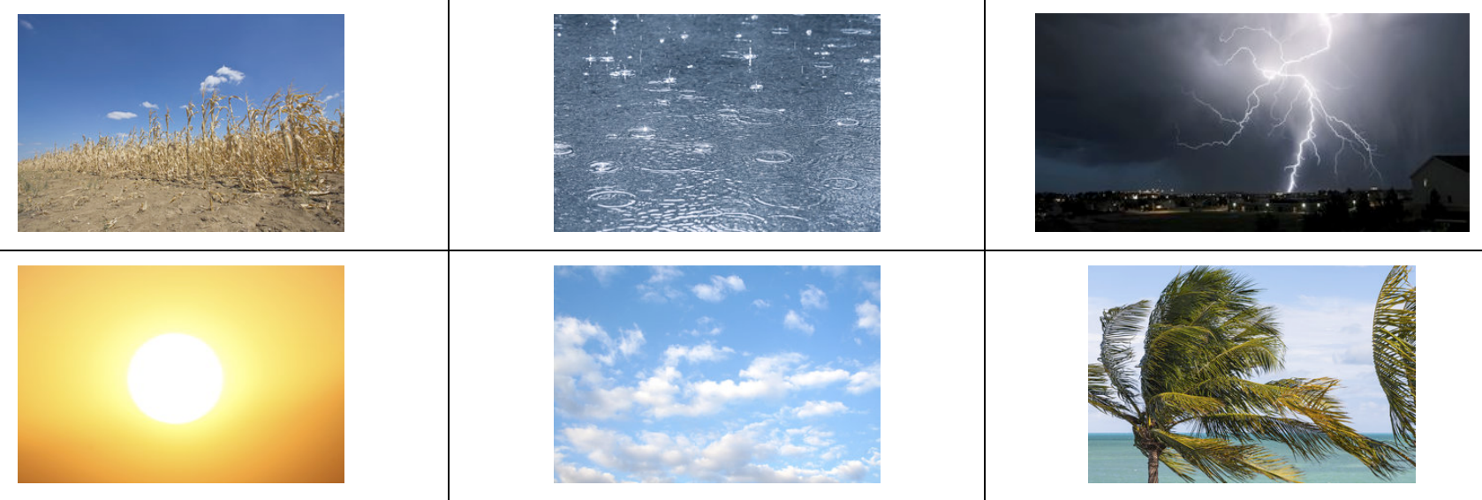

rainy windy thunderstorm
sunny dry cloudy

Exercise 2
What is the weather usually like in your city or town?
例) It’s usually … (hot / cold / windy etc.)

What kind of weather do you like?
例) I like … (hot weather / cold weather / sunny weather etc.)

Exercise 3
Listen carefully and match the two parts together.

The weather in the north is mostly · · rainy
The weather in the east is mostly · · cloudy and sunny
The weather in the west is mostly · · dry and cloudy
The weather in the south is mostly · · windy.

(Mostly - ほとんど)
Exercise 4
Listen carefully and fill in the gaps
1. Welcome to the weather forecast. Now, let’s see what the weather is _______________ today.

2. In the north of the country it’s very windy and cold. There is a _______________ of some rain, too.

3. The temperature is around 10 _______________ centigrade.

4. In the east it’s rainy all day today, I’m afraid. There may be a thunderstorm in the afternoon. The _______________ is a bit higher, at around 13 degrees.

5. In the west and middle of the country the weather is dry _______________ cloudy.

6. The south of the country has the _______________ weather today. It’s cloudy most of the time but sunny this afternoon.

best temperature degrees
chance but like

