Name: ________________ Class: ___ Number: ____ Date: ____/____
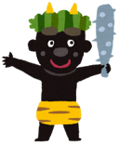
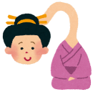
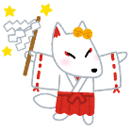
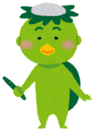
YOKAI WAR
YEAR END REVIEW
- ___________________________________________________________________
- ___________________________________________________________________
- ___________________________________________________________________
- ___________________________________________________________________
- ___________________________________________________________________
- ___________________________________________________________________
- ___________________________________________________________________
- ___________________________________________________________________
- ___________________________________________________________________
- ___________________________________________________________________
- ___________________________________________________________________
- ___________________________________________________________________
What was your best memory in Junior High School?
_____________________________________________________________________
_____________________________________________________________________
_____________________________________________________________________
What do you want to do in high school?
_____________________________________________________________________
_____________________________________________________________________
_____________________________________________________________________
What do you have to do next year? What must you not do next year?
_____________________________________________________________________
_____________________________________________________________________
_____________________________________________________________________

