Let’s Try 2, unit 1: What _____ do you like?
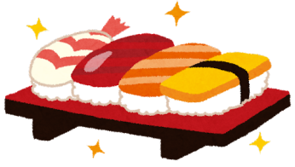

What food do you like?

I like…

What sport do you like?

I like…

What color (色) do you like?

I like…

