Where are they originally eaten ②?

Continue learning about different foods and most importantly let’s get interested in foreign foods… yummy!
Let’s start!
- Fondue  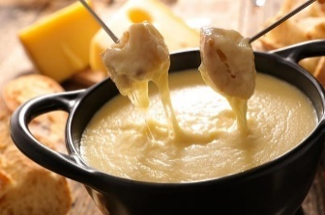 | - Doner Kebab  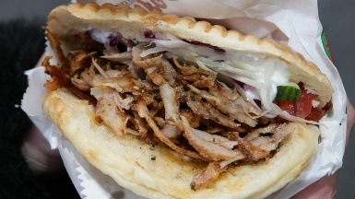 | - Jerk Chicken  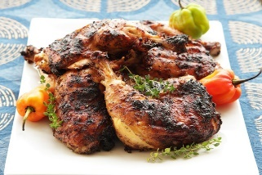
_______________ | _______________ | _______________

- Beef Noodle Soup  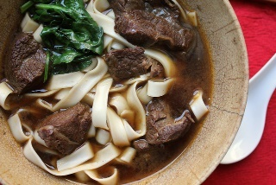 | - Haggis  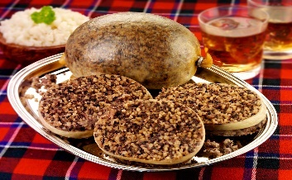 | - Waffles
_______________ | _______________ | _______________

- Lamingtons  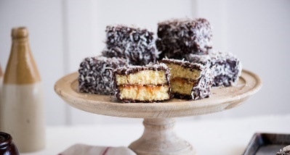 | - Princess Cake  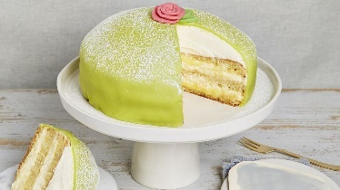 | - Soufflé Pancakes
_______________ | _______________ | _______________
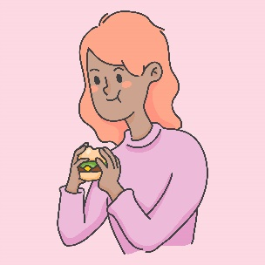
Bon Appetit!
Questions
- What do you want to try the most? ______________________________
- Which dish looks the most delicious? ______________________________
- What can be eaten in Europe? _______________________________________
- Which do you prefer, salty or sweet foods? _______________________________________
- What can you eat every day and not get tired of it? _________________________________
Name ( ) Class ( ) No ( )

