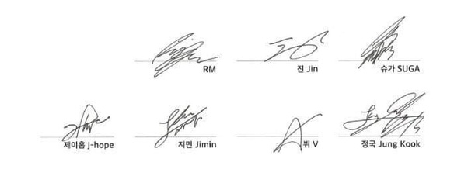

［任意］Make your own signature!

(例) BTS’ Signature:

日付

内容 (感謝の言葉；思い出；今後のこと；追加情報など)

______________________________________________

___________________________________________________

___________________________________________________

___________________________________________________

___________________________________________________

___________________________________________________

___________________________________________________

______________________________________________

___________________________________________________

まとめ（結び）

終わりのあいさつ

___________________,

___________________

署名

導入

_________________, 20___

______________________________________________

___________________________________________________

Dear _______________________,

Thank You!