Hi, how are you?

I’m fine, thanks, and you?

I’m good, thanks.

What did you do on Sunday?

I went to the mountains. I saw flowers. It was beautiful.

Wow! That’s great.

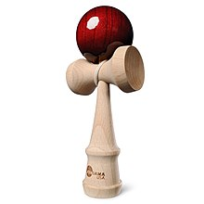
What did you do on Sunday?

I went to my friend’s house. We saw a movie. It was interesting.

Cool. What did you see?

I saw Harry Potter.

