Name
What time do you BINGO?
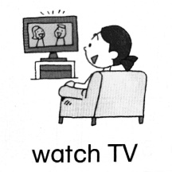 | 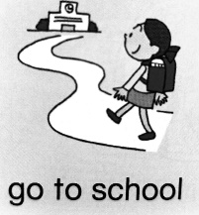 | 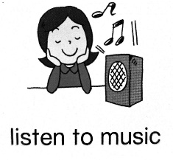 | 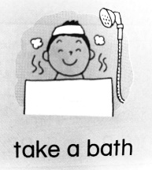
4:30 | 7:15 | 7:05 | 6:45 | 4:45
5:00 | 6:45 | 7:15 | 7:00 | 5:00
6:00 | 7:00 | 8:45 | 7:15 | 10:00
7:00 | 6:00 | 5:30 | 8:30 | 11:15
8:00 | 6:30 | 7:00 | 8:45 | 12:30

Name
What time do you BINGO?
6:00 | 7:45 | 5:05 | 8:45 | 4:45
7:00 | 8:00 | 4:15 | 7:30 | 5:00
8:00 | 6:00 | 4:30 | 7:45 | 10:00
8:30 | 6:45 | 5:00 | 8:00 | 11:15
9:00 | 7:00 | 8:45 | 8:05 | 12:30

Name
What time do you BINGO?
5:00 | 6:45 | 5:30 | 7:45 | 4:30
6:00 | 7:00 | 7:00 | 8:00 | 11:15
7:00 | 7:45 | 7:05 | 6:45 | 12:30
8:00 | 8:00 | 7:15 | 7:00 | 4:45
8:30 | 6:00 | 8:45 | 7:15 | 5:00

Name
What time do you BINGO?
4:30 | 7:45 | 5:30 | 8:05 | 4:15
5:00 | 8:00 | 7:00 | 6:45 | 4:30
6:00 | 7:15 | 7:05 | 7:00 | 4:45
7:00 | 6:45 | 7:15 | 7:15 | 5:00
8:00 | 7:00 | 8:45 | 8:30 | 12:30

Name
What time do you BINGO?
7:00 | 7:00 | 4:15 | 8:00 | 4:45
4:30 | 7:15 | 4:30 | 8:05 | 5:00
5:00 | 7:30 | 5:00 | 6:45 | 5:00
6:00 | 7:45 | 5:05 | 7:00 | 12:30
9:00 | 8:00 | 8:45 | 8:00 | 11:15

Name
What time do you BINGO?
7:00 | 6:45 | 4:15 | 7:45 | 11:15
8:00 | 7:00 | 4:30 | 8:00 | 12:30
4:30 | 7:15 | 5:00 | 8:05 | 4:45
5:00 | 7:30 | 5:05 | 8:30 | 5:00
6:00 | 7:45 | 5:30 | 8:45 | 10:00

Name
What time do you BINGO?
4:30 | 6:30 | 4:15 | 6:45 | 4:15
5:00 | 6:45 | 4:30 | 7:00 | 4:30
8:00 | 7:00 | 5:00 | 7:15 | 11:15
8:30 | 7:15 | 5:05 | 7:30 | 12:30
9:00 | 7:30 | 5:30 | 7:45 | 4:30

Name
What time do you BINGO?
8:00 | 6:00 | 5:30 | 7:45 | 4:45
8:30 | 6:30 | 7:00 | 8:00 | 5:00
9:00 | 6:45 | 7:05 | 8:05 | 10:00
4:30 | 7:00 | 7:15 | 8:30 | 4:30
5:00 | 7:15 | 8:45 | 8:45 | 11:15

Response Sheet
4:30 | 6:00 | 4:15 | 6:45 | 4:15
5:00 | 6:30 | 4:30 | 7:00 | 4:30
6:00 | 6:45 | 5:00 | 7:15 | 4:45
7:00 | 7:00 | 5:05 | 7:30 | 5:00
8:00 | 7:15 | 5:30 | 7:45 | 10:00
8:30 | 7:30 | 7:00 | 8:00 | 11:15
9:00 | 7:45 | 7:05 | 8:05 | 12:30
 | 8:00 | 7:15 | 8:30
 |  | 8:45 | 8:45
What time do you BINGO?

