Hi, how are you?

I’m fine, thanks, and you?

I’m good, thanks.

What did you eat this morning?

I ate a sandwich and salad. It was good.

Nice. I like sandwiches.

Cool. What did you eat this morning?

I ate rice and miso soup. It was delicious.

Wow! I don’t like miso soup.

Really? I like fried eggs.

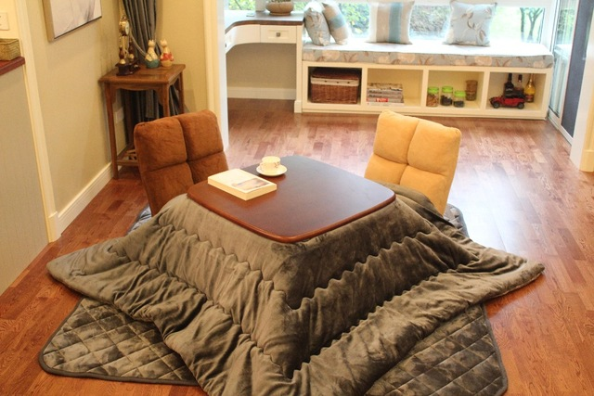
Oh! Me, too!

